**DAILY ONLINE ACTIVITIES SUMMARY**

|  |  |  |  |  |  |  |  |  |
| --- | --- | --- | --- | --- | --- | --- | --- | --- |
| **Date:** | **01/06/2020** | | | | | **Name:** | **AKASH S** | |
| **Sem & Sec** | **4TH&A** | | | | | **USN:** | **4AL18CS004** | |
| **Online Test Summary** | | | | | | | | |
| **Subject** | | **COMPLEX ANALYSIS,PROBABILITY AND STASTICAL METHOD** | | | | | | |
| **Max. Marks** | | **30** | | **Score** | | | **29** | |
| **Certification Course Summary** | | | | | | | | |
| **Course** | **CLOUD FOUNDATIONS** | | | | | | | |
| **Certificate Provider** | | | **GREATLEARNING** | | **Duration** | | | **4.5 HOURS** |
| **Coding Challenges** | | | | | | | | |
| **Problem Statement 1:** **Write a java program to calculate distance between points p1 and p2.**  **Problem Statement 2:write a java program to find nPr.** | | | | | | | | |
| **Status: executed** | | | | | | | | |
| **Uploaded the report in Github** | | | | | **YES** | | | |
| **If yes Repository name** | | | | | <https://github.com/akashacharya786/lockdown-c-coding>  **https://github.com/akashacharya786/lockdown-java-coding** | | | |
| **Uploaded the report in slack** | | | | | **YES** | | | |

Online Test Summary: 18MAT41 online test was scheduled from 9:25am to 10:10 am. The portion for the IA was 5th module. The question were MCQ type There were 30 question 1 mark respectively duration is 40 minutes .The score I received was 29/30.

Snap shot:

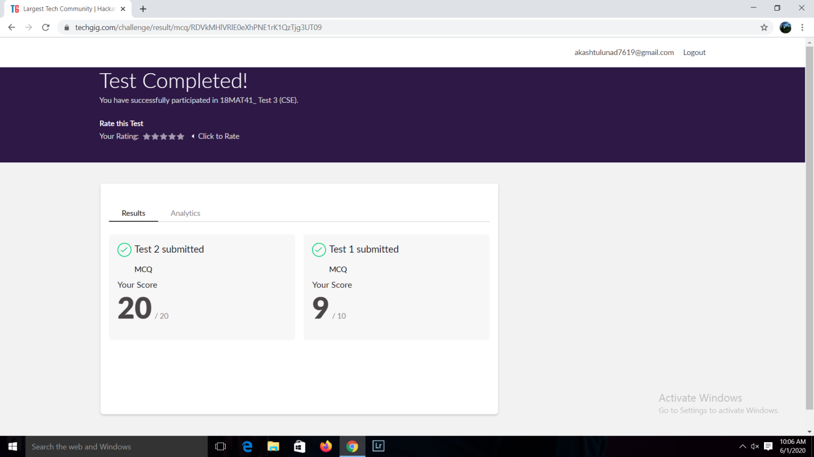

**Online Certification course:**

Name of the course : cloud foundations

Duration:4.5 hours

Certificate provider: great learning

Today I have successfully completed the cloud foundations certification course.

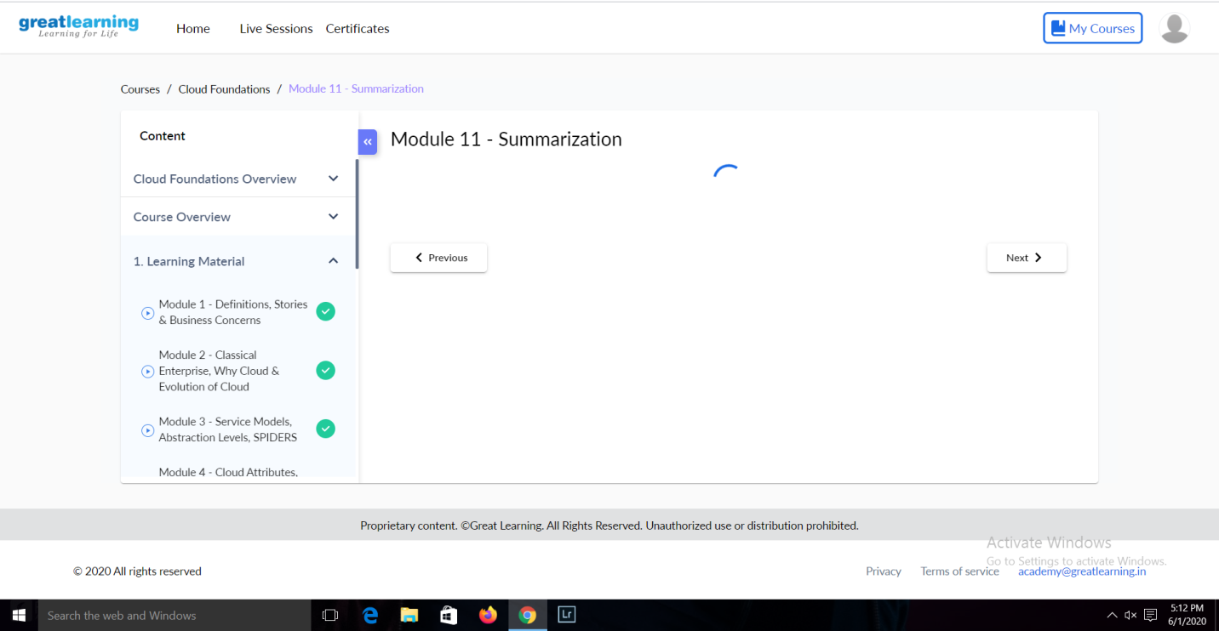

Online Coding summary:

1.Write a java program to calculate distance between points p1 and p2.

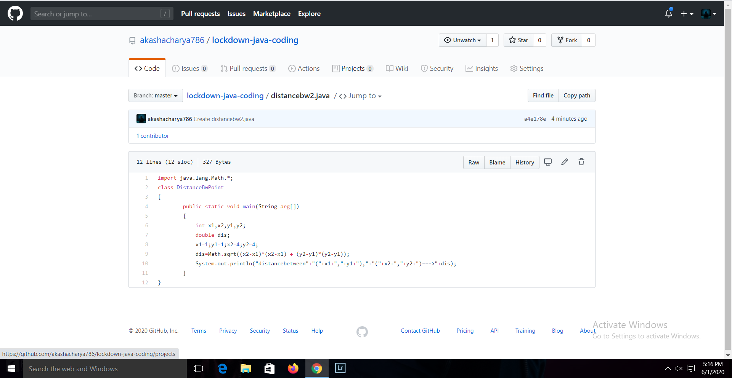

2.write a java program to find nPr.

